|  |  |  |  |  |  |
| --- | --- | --- | --- | --- | --- |
| Date | 14-Dec-22 | | | Tester Name | Richard Belanger |
| Environment | Penfax - Test | | | Login used | TEST2 |
| Operating System | Windows | Version: | Update: | | |
| Software Used | Edge | Version: | Update: | | |
| Not Applicable | Version: | Update: | | |
| Release version | 22.4.1 | | | | |
| Title | M3.02 Change an Employee's Employment Status via DCT | | | | |
| Test Type | Regression | | | | |
| Test Scenario | Change EE’s Employment Status through DCT file | | | | |
|  |  | | | | |
| Expected Results | The EE’s Employment Status will be changed | | | | |
| Pass/Fail | Pass | | | JIRA# | N/A |

Describe your steps with screenshots:

Member is a 12 Month member employed by Parkland Regional Library

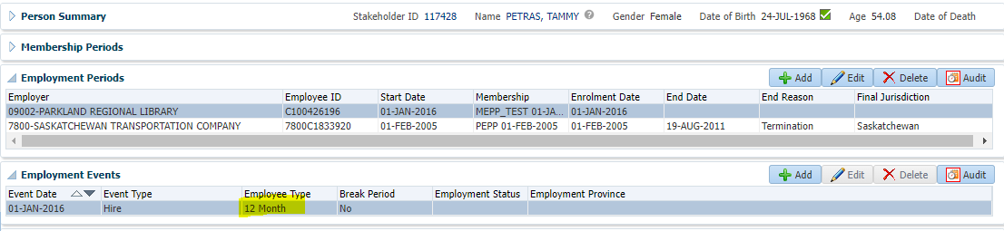

Log into DCT >Select ER from the drop down and click on Create New File

Select Data Change from the drop down -> click on Create

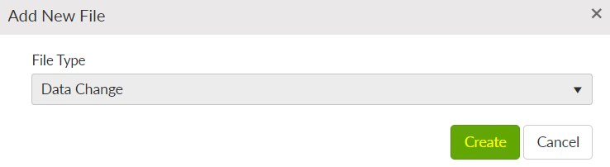

Click on File ID

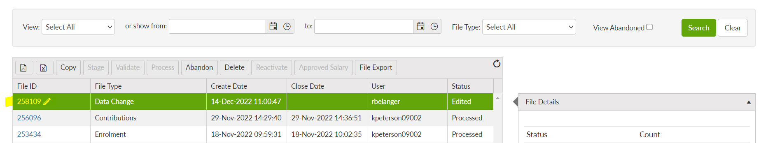

Click on Add

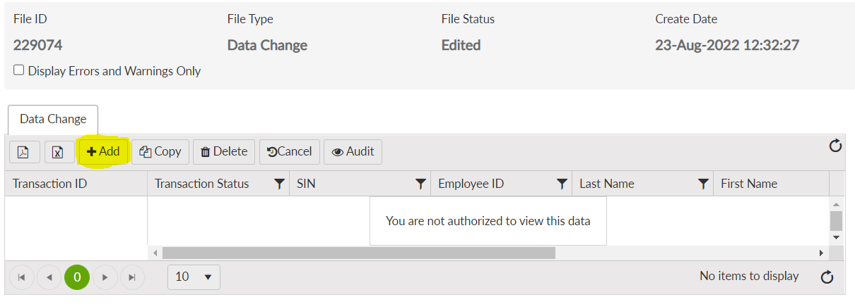

Save

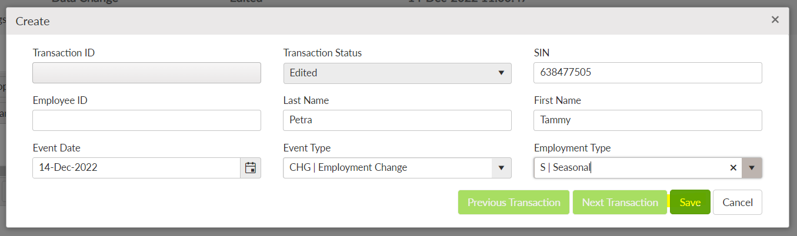

File Processed

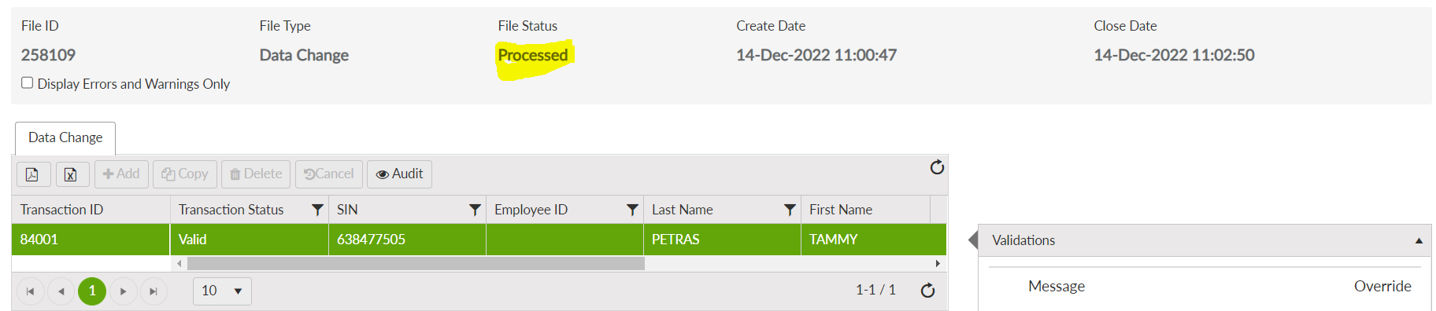

Penfax > Batch Processes -> Data Posting Batch

Search by employer name and open the data posting batch having DCT file you just processed.

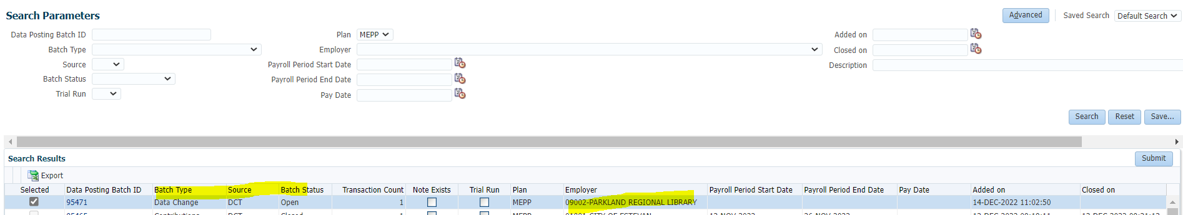

Changed in PENFAX

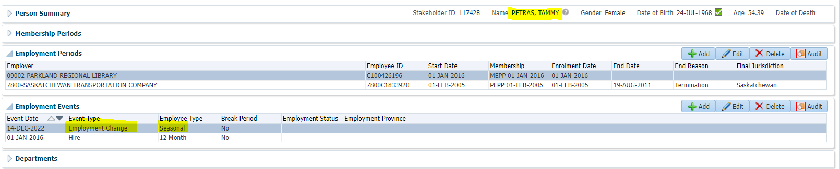

Audit Button to see activity

